**Revision Sheet – Theme 2: The Natural Environment**

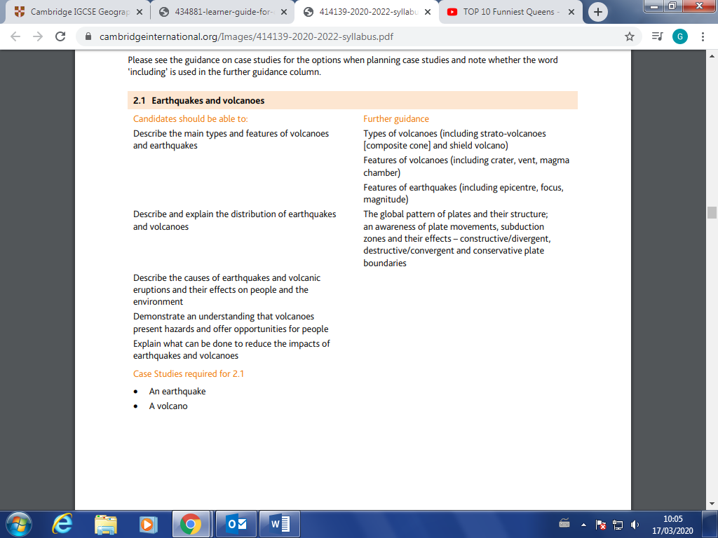

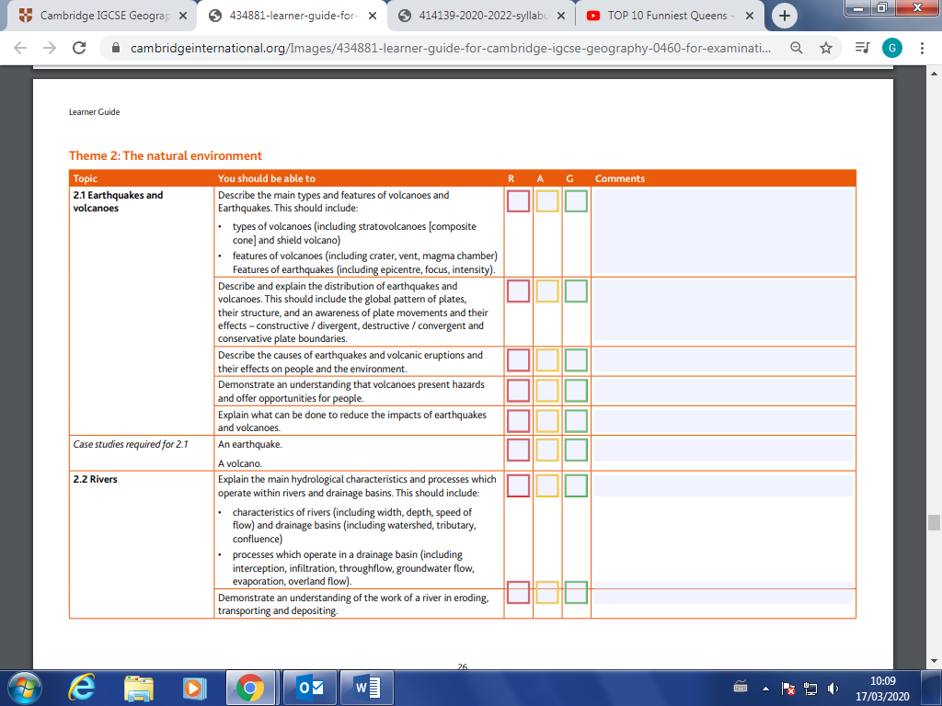

|  |  |  |  |
| --- | --- | --- | --- |
| Case Study | I can explain the case study | Can remember two facts: | Can remember three facts: |
| Volcanoes: The Montserrat Eruption |  |  |  |
| Earthquake: The Christchurch Earthquake, New Zealand & Nepal Earthquake |  |  |  |

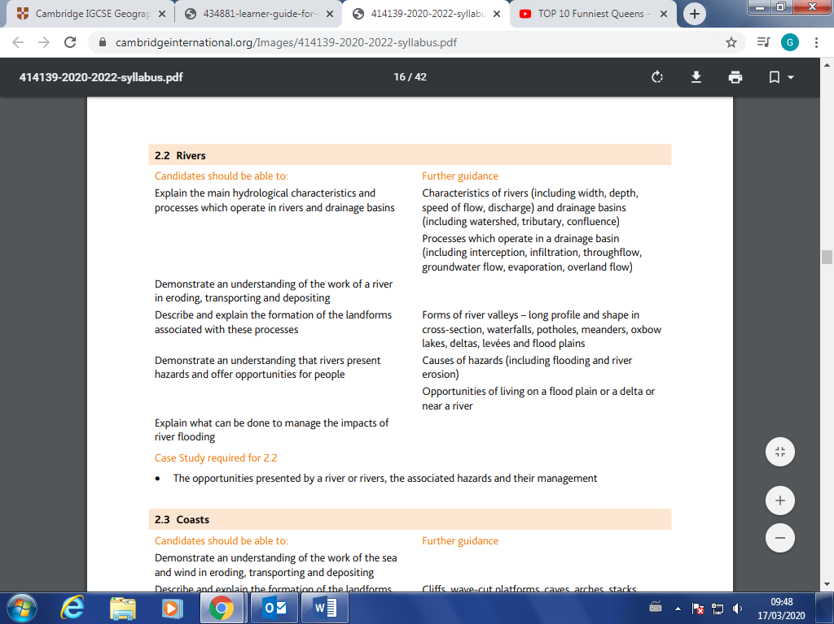

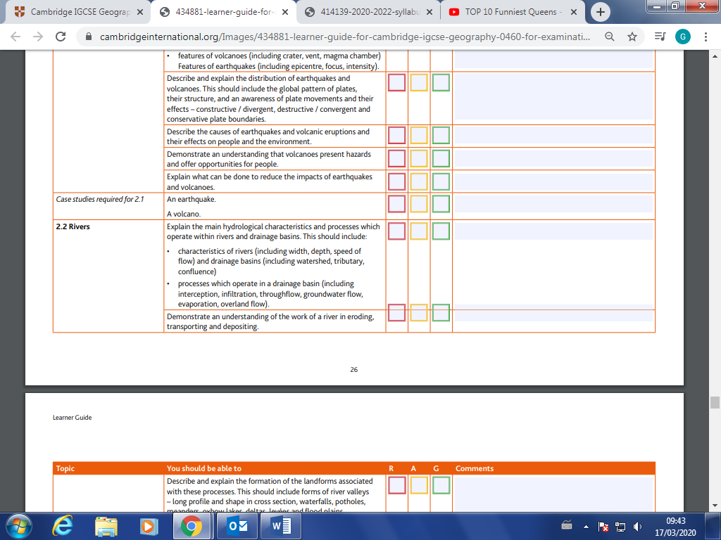

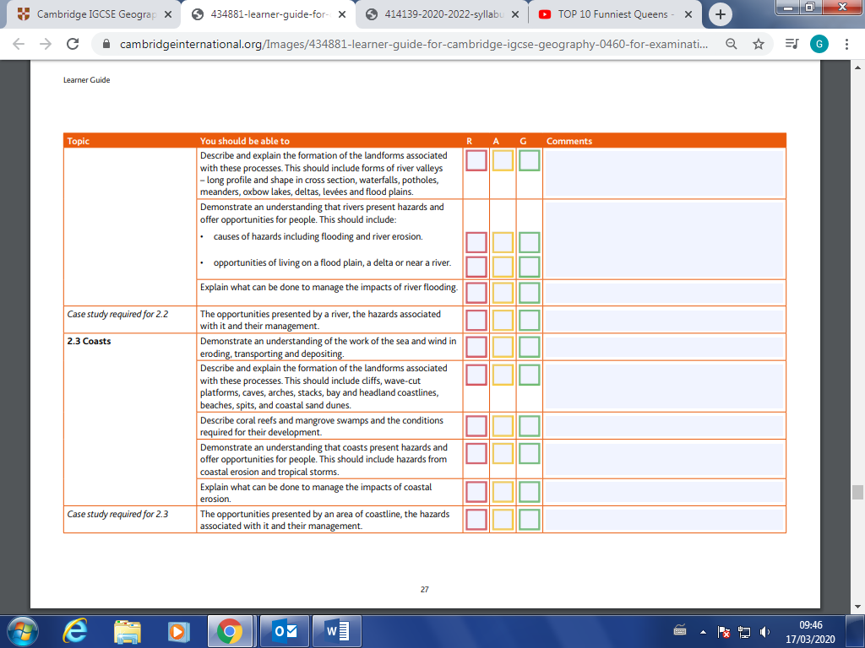

|  |  |  |  |
| --- | --- | --- | --- |
| Case Study | I can explain the case study | Can remember two facts: | Can remember three facts: |
| Waterfalls: Niagara, USA/Canada & Victoria Falls, Zambia |  |  |  |
| Opportunities and hazards: The Rhone Delta, France |  |  |  |
| Hard Engineering: The Three Gorges Dam, China |  |  |  |

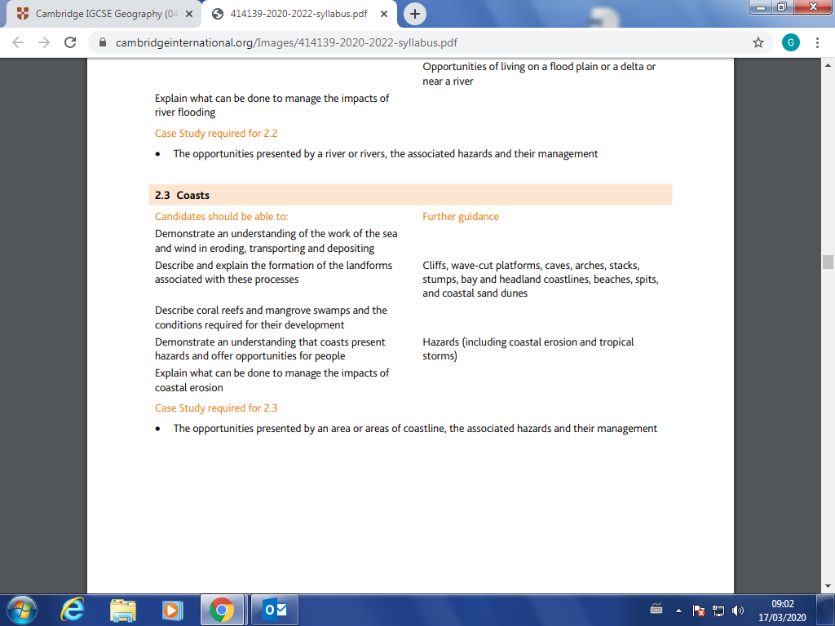

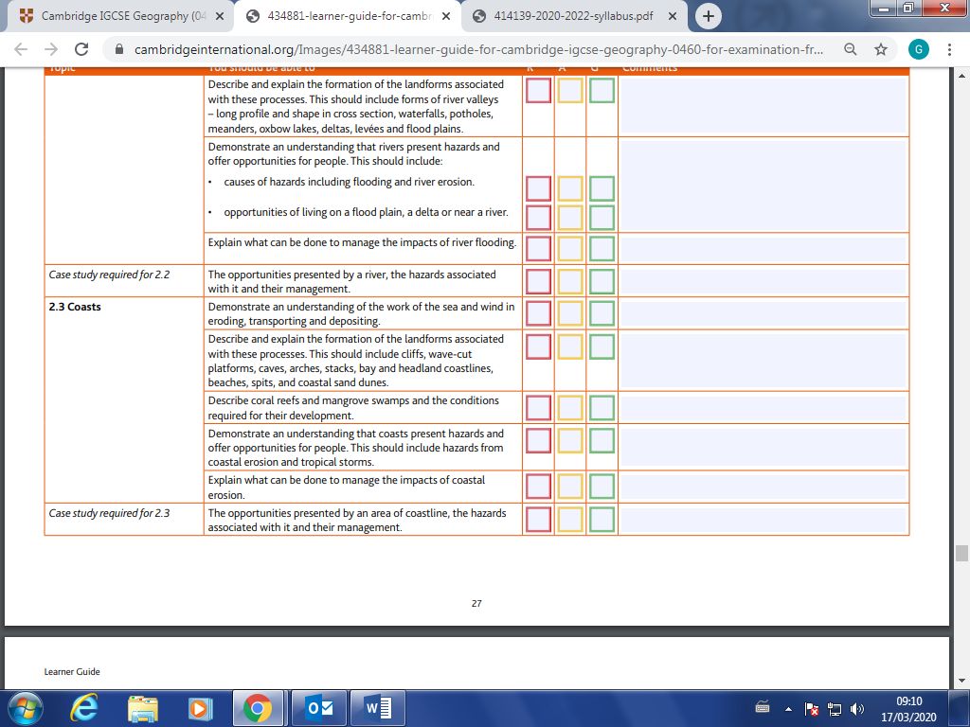

Case Studies:

|  |  |  |  |
| --- | --- | --- | --- |
| Case Study | I can explain the case study | Can remember two facts: | Can remember three facts: |
| Erosion of the Eastern USA’s Coast |  |  |  |
| Coastal hazards: Typhoon Haiyan |  |  |  |
| Management (soft eng) Miami Beach |  |  |  |
| Management (hard eng) Palisadoes, Jamaica |  |  |  |
| Impacts of tourism: St Lucia |  |  |  |
| Coastal Development: Dubai |  |  |  |

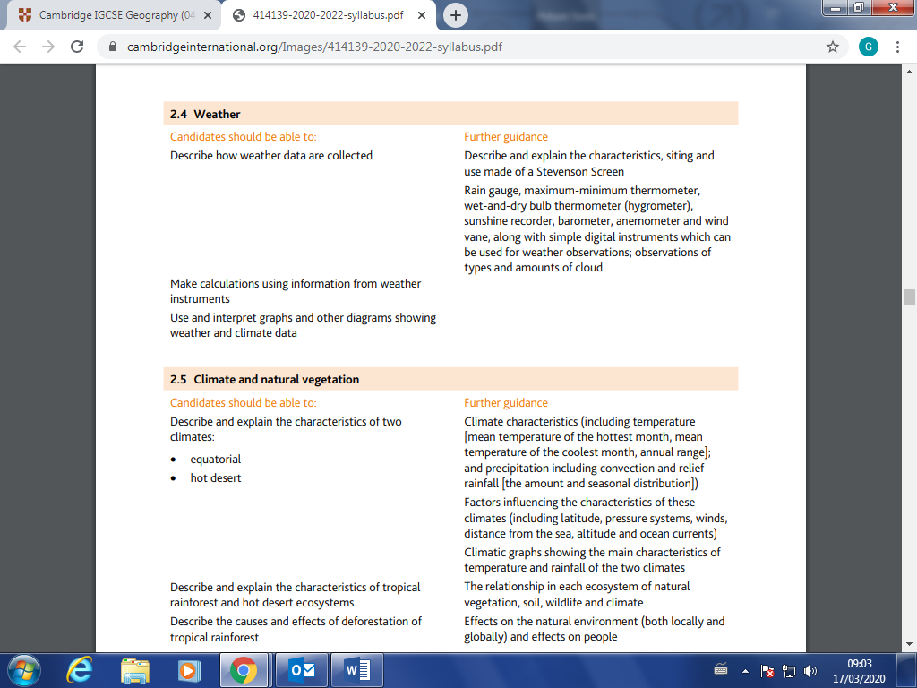

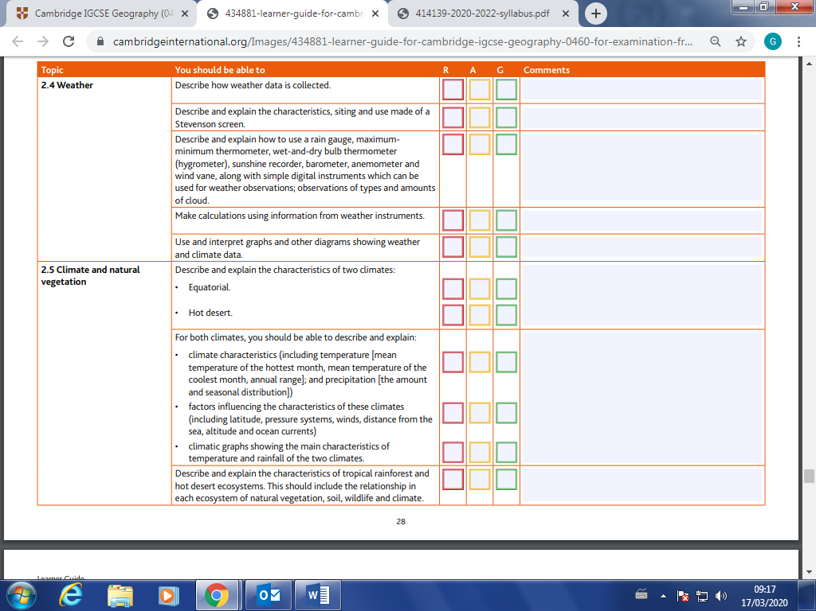

|  |  |  |  |
| --- | --- | --- | --- |
| Case Study | I can explain the case study | Can remember two facts: | Can remember three facts: |
| No case studies for weather – you will be asked resource based questions for this topic across papers 1, 2 & 4. |  |  |  |

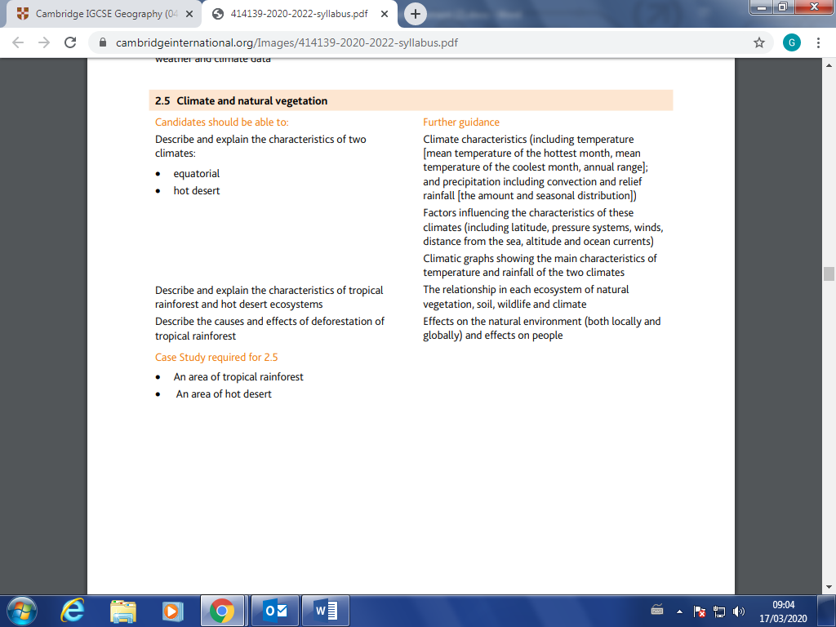



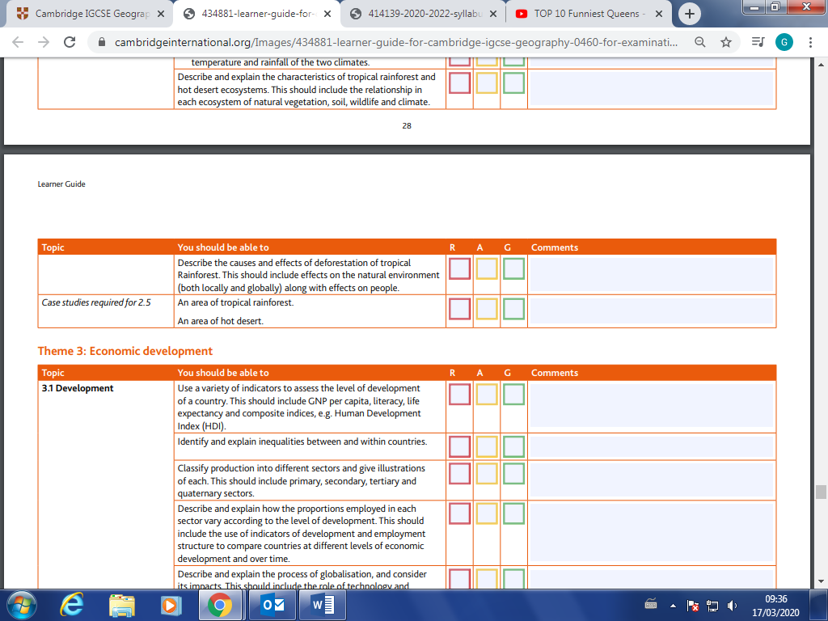

|  |  |  |  |
| --- | --- | --- | --- |
| Case Study | I can explain the case study | Can remember two facts: | Can remember three facts: |
| Rainforest: The Danum Valley Conservation area, Malaysia |  |  |  |
| Desert: The Sonoran Desert, USA |  |  |  |